OFFICE OF THE DIRECTOR  Office of the State Public Health Director | 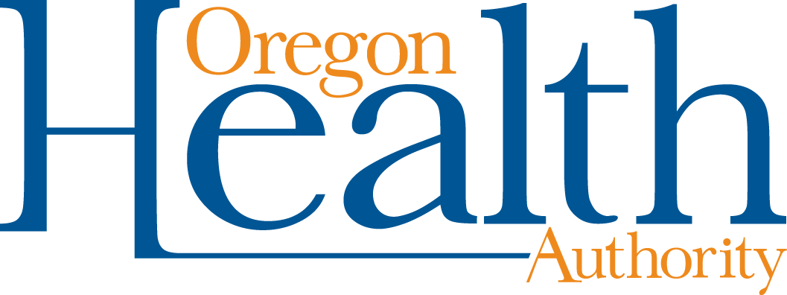

COVID-19 Vaccine Religious Exception Request Form
I am requesting an exception from the COVID-19 vaccination on the basis of a sincerely held religious belief.
Individual’s name: | Date of birth:
Phone number:

Employer/Organization: | Job Title/Position:

Please check the boxes below as appropriate and complete related questions:
Receiving the COVID-19 vaccination conflicts with my religious observances, practices or beliefs as described below.
Please describe your religious belief and how it affects your ability to receive a COVID-19 vaccination

I certify the above information to be true and accurate and that I sincerely hold the religious beliefs described above.
Signature: | Date:
Please note that if your exception request is approved, you may be required by your employer or other responsible party to take additional steps to protect you and others from contracting and spreading COVID-19. Workplaces are not required to provide this exception accommodation if doing so would pose a direct threat to the excepted individual or others in the workplace or would create an undue hardship.
Document accessibility: For individuals with disabilities or individuals who speak a language other than English, OHA can provide information in alternate formats such as translations, large print, or braille. Contact the Health Information Center at 1-971-673- 2411, 711 TTY or COVID19.LanguageAccess@dhsoha.state.or.us.

